Cooperative Skills Challenge
2019

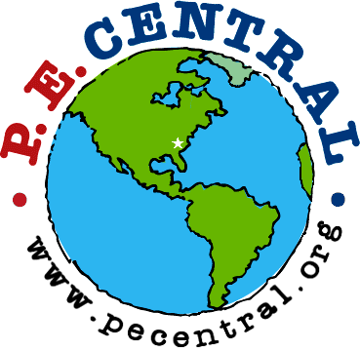



PE Central and S&S Worldwide

are proud to recognize

Participant Name

for earning a BRONZE certificate by successfully completing
4 of the 6 Cooperative Skills Challenges at

on

School Name Date
Teacher

PE Central
www.pecchallenge.org

