Cooperative Skills Challenge

2019

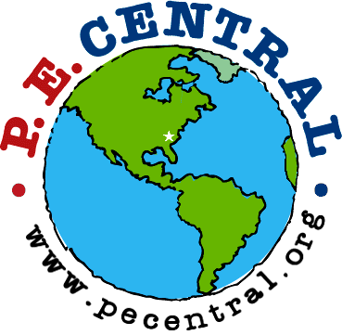



PE Central and S&S Worldwide

are proud to recognize

Participant Name

for earning a GOLD certificate by successfully completing
6 of the 6 Cooperative Skills Challenges at

on
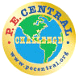
School Name Date
Teacher

PE Central
www.pecchallenge.org

