Cooperative Skills Challenge

2019

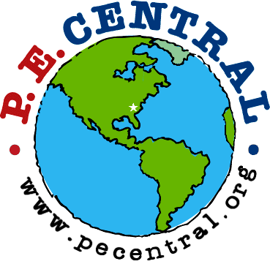



PE Central and S&S Worldwide

are proud to recognize

Participant Name

for PARTICIPATION and EXCEPTIONAL EFFORT
in the Cooperative Skills Challenge at

on
School Name Date
Teacher

PE Central
www.pecchallenge.org

